Graph 1 – attacks all over the globe

Graph – dateTime vs timedifference
timeline of attacks vs the time diferrence i.e. the difference pretween the former and later attack
colour by Month

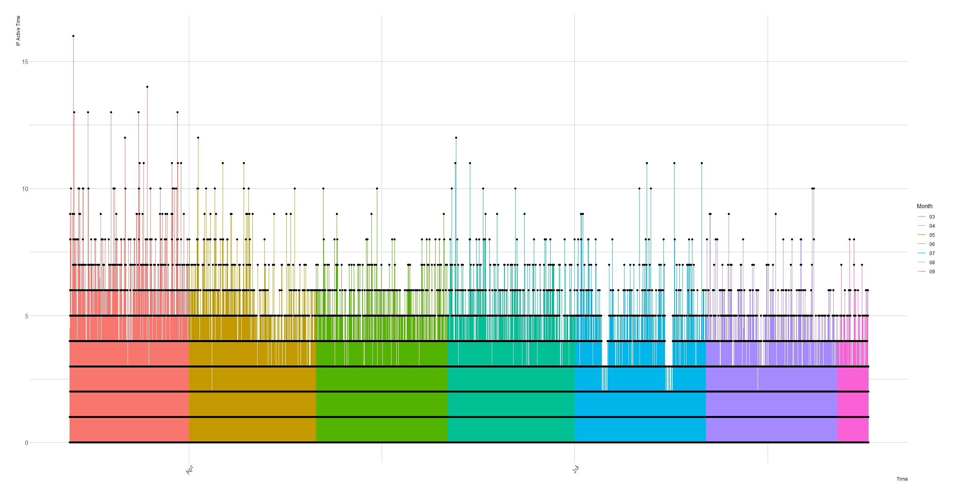

Colour by – country
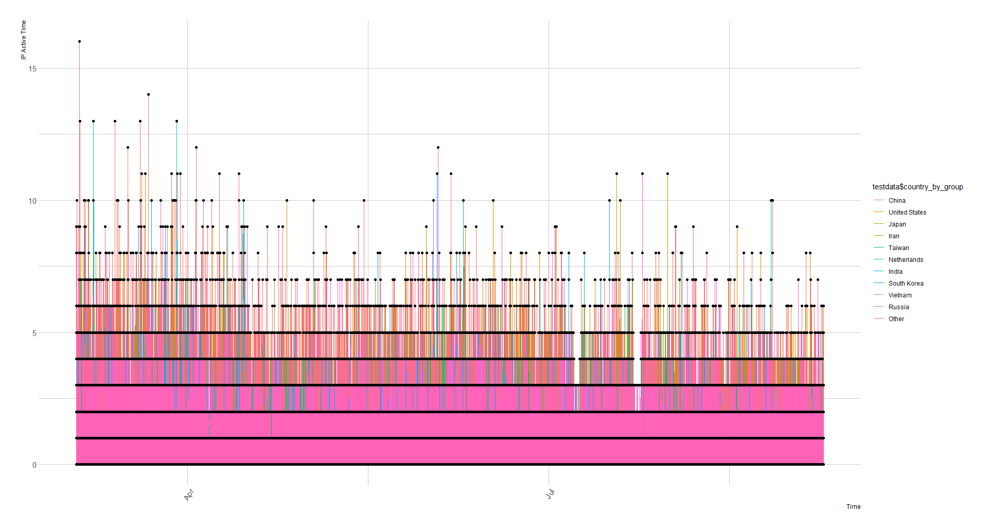
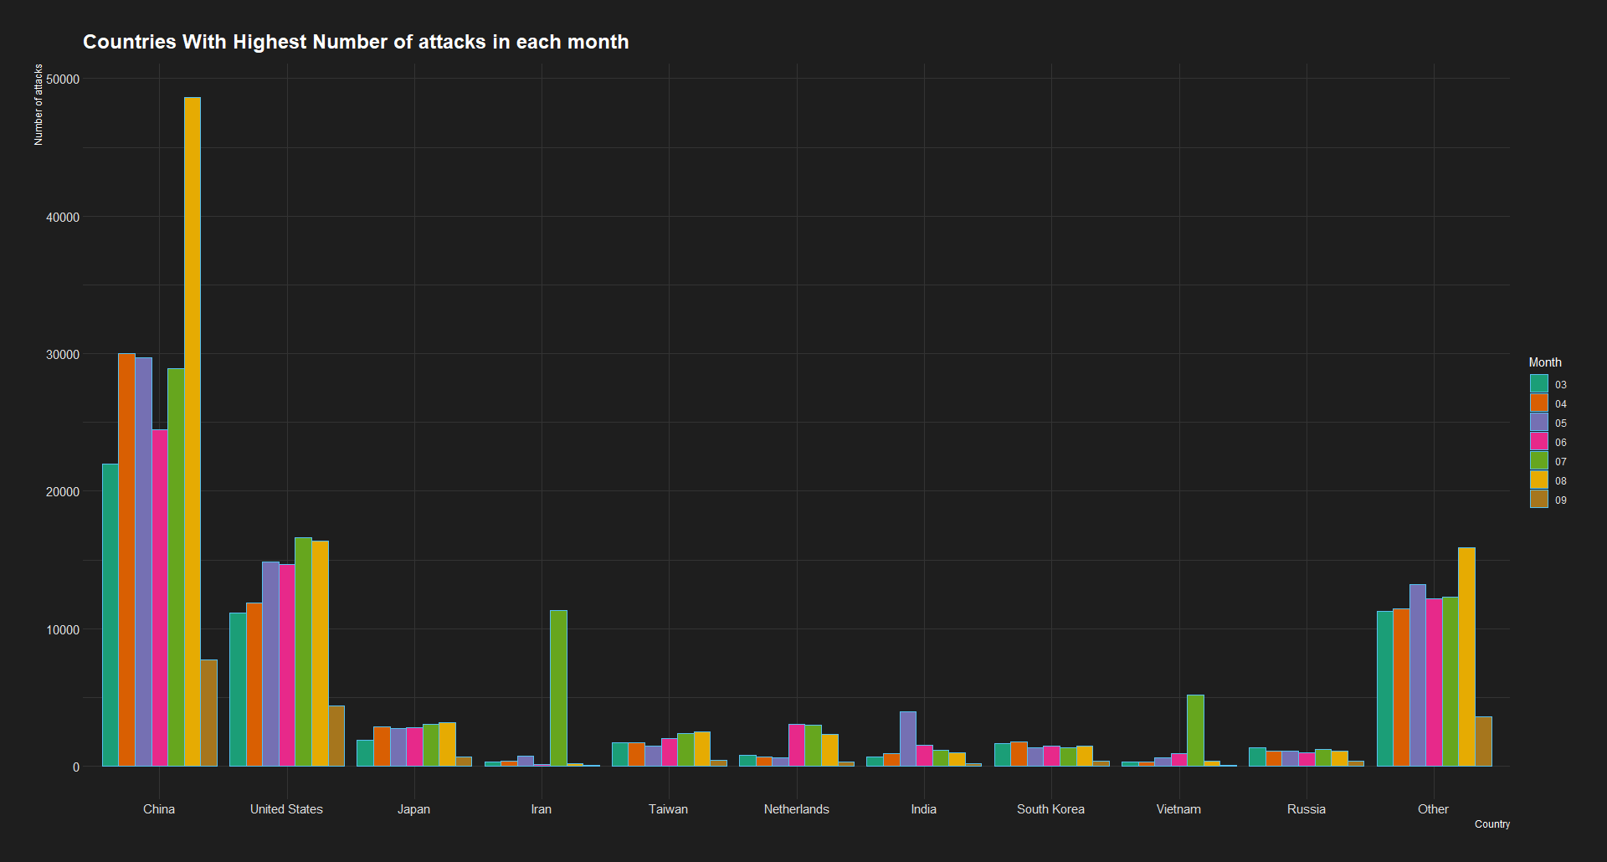

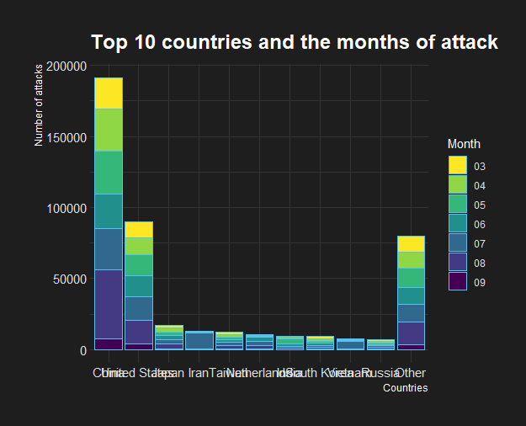

Attacks per day Month wise for top 10 countries

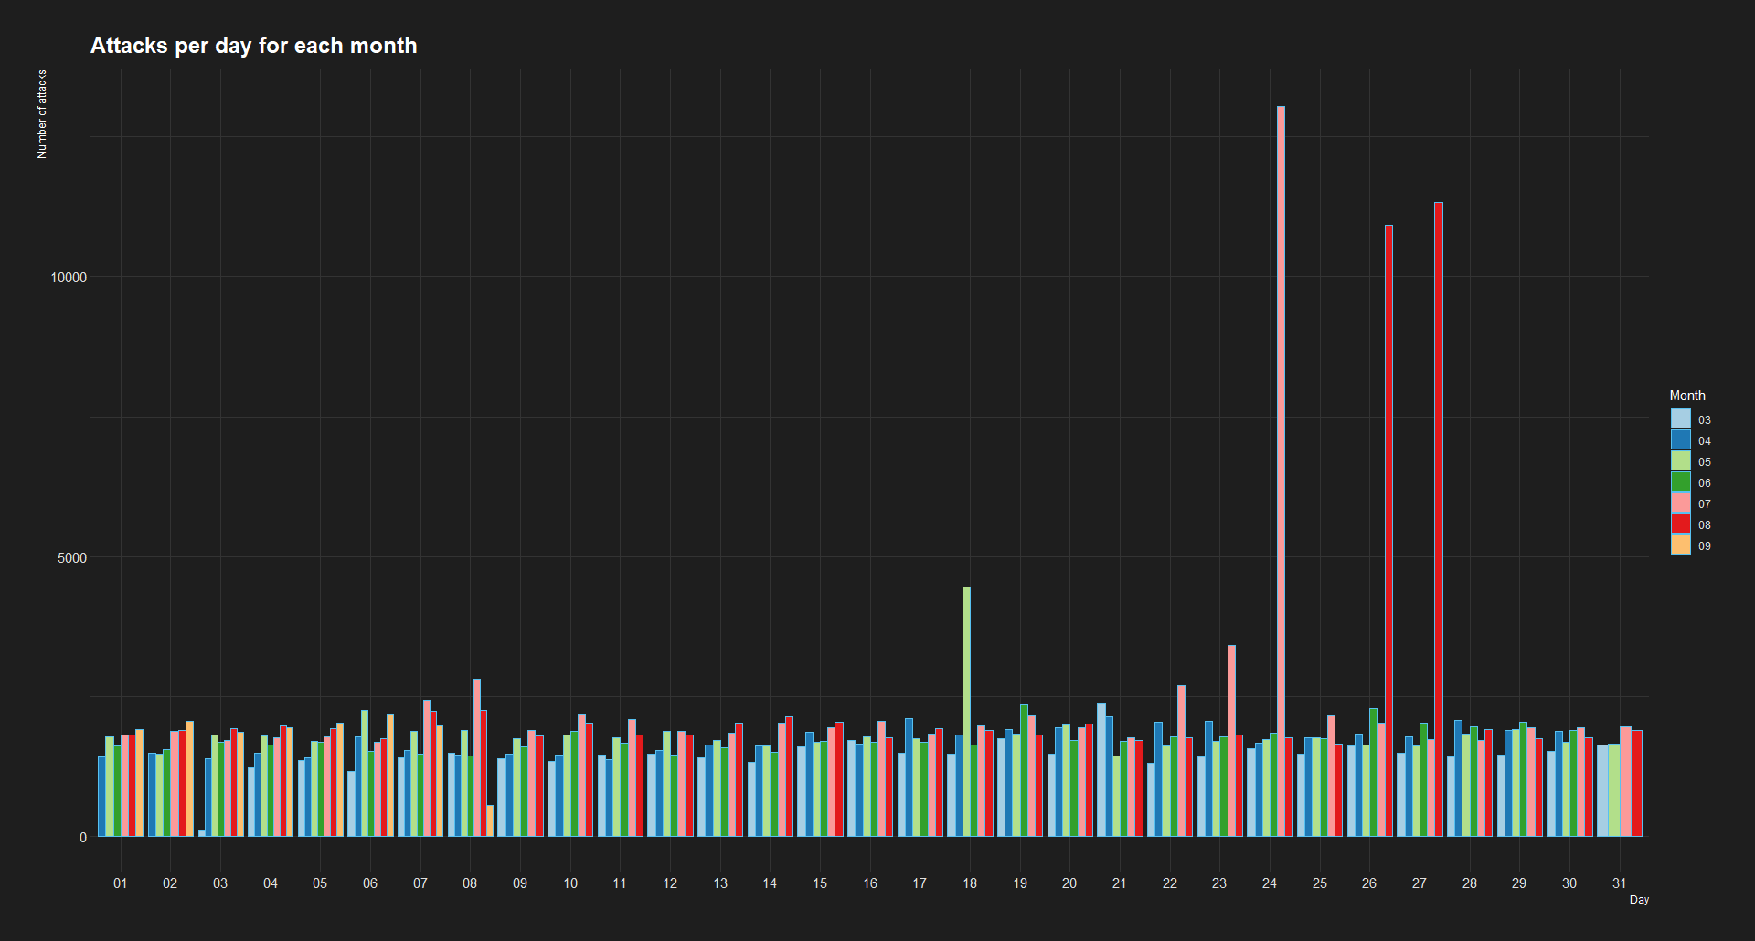

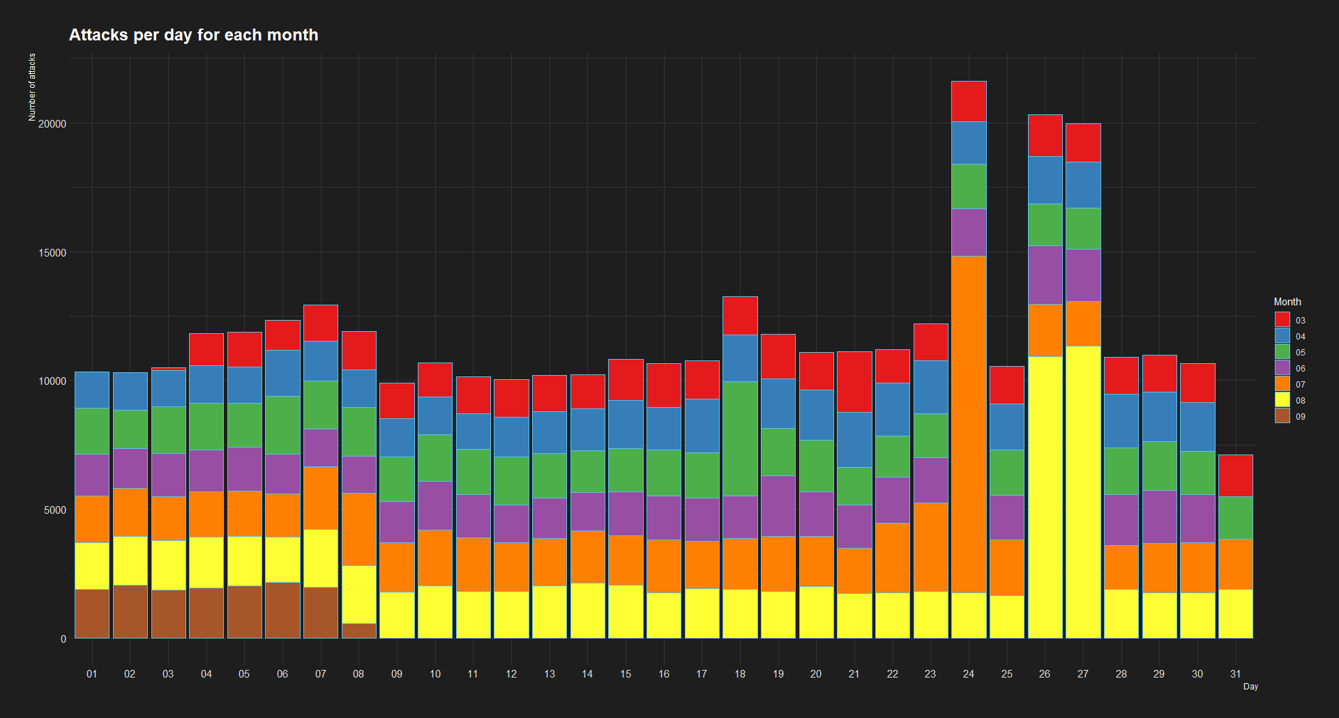

Attacks Each day

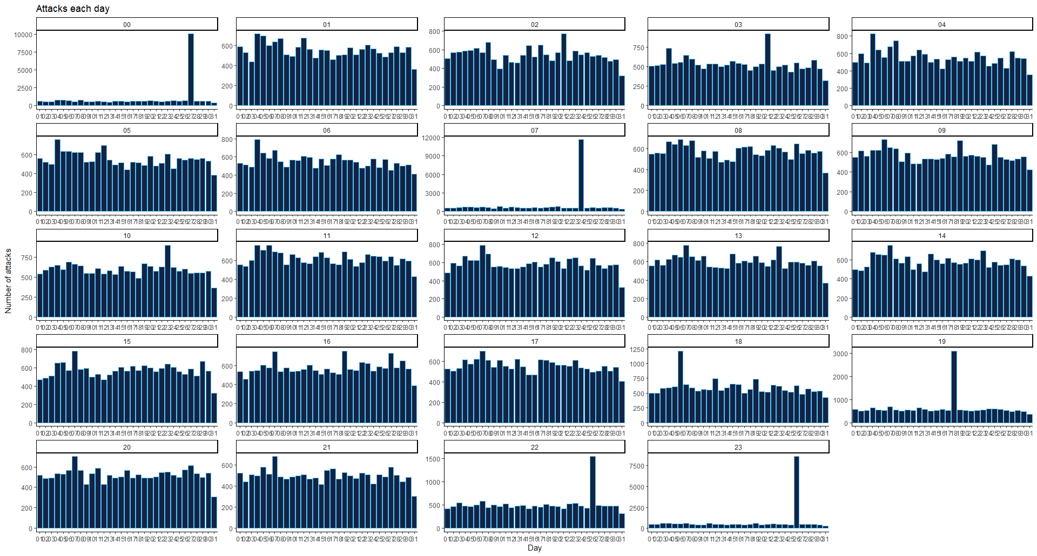

Top 10 bad Ips with top 10 countries each month
